Step1: RawData_set in JSON (EAGLEEYE_OCC_CAMPAIGN_DETAILS):

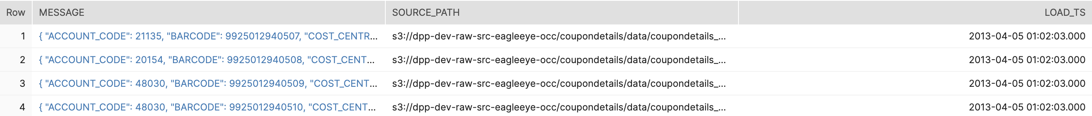

Step2: Parse Data Set (EAGLEEYE_OCC_CAMPAIGN_DETAILS_BATCH_LOAD)

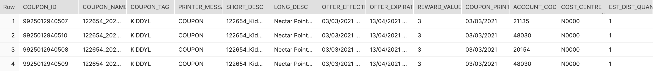

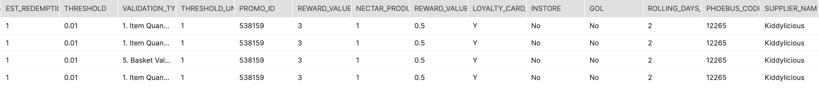

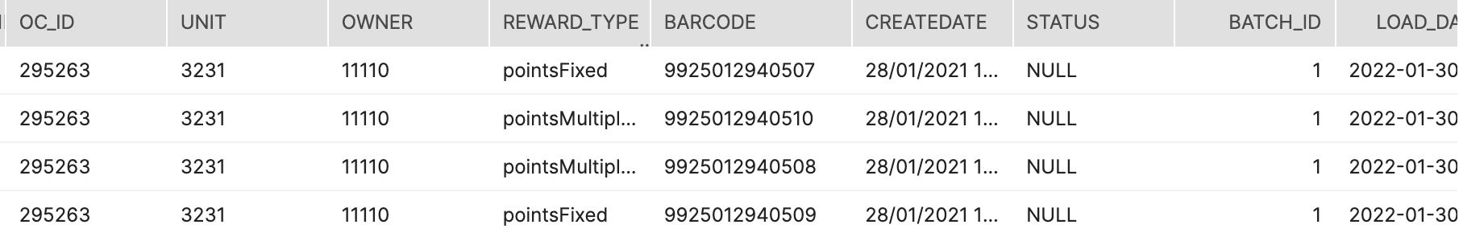

Step3: data in View

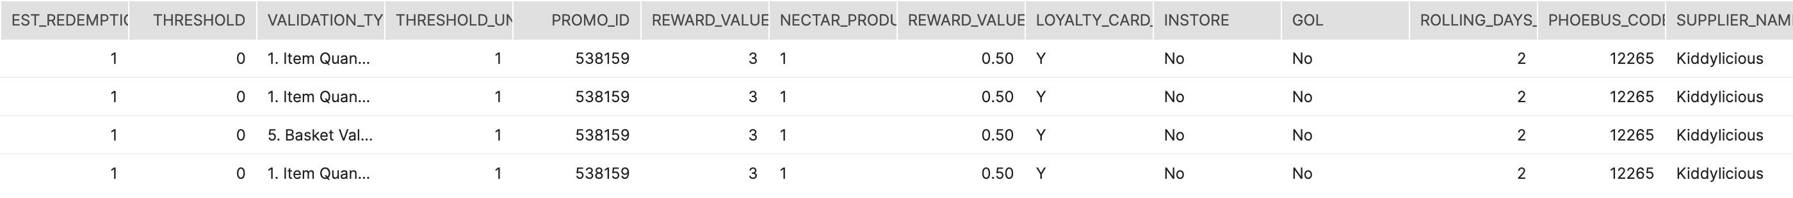

Step4: Data in SAT

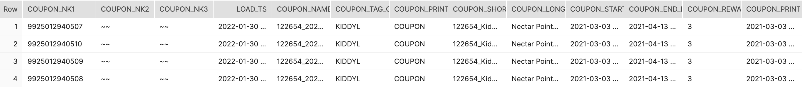

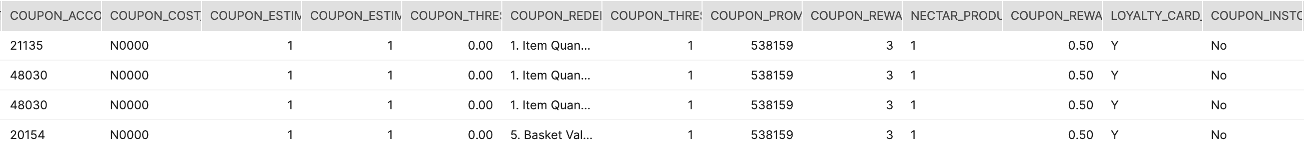

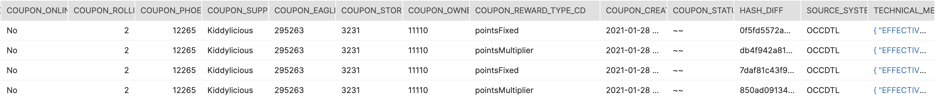

Step5: Data in BDV



